B.Well
Medical devices for the whole family

- Automatic blood presure monitors

PRO – 33
B.Well Swiss

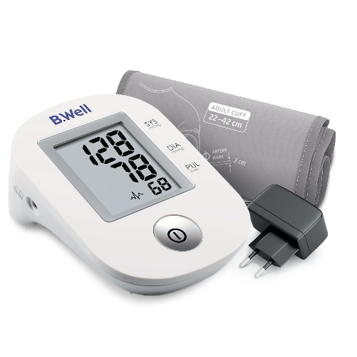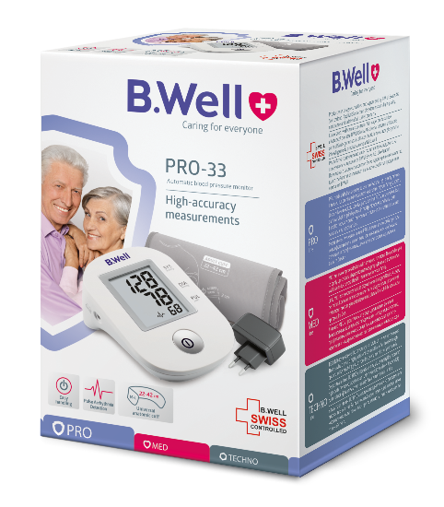

The automatic blood pressure monitor PRO-33 is easy to use and has a precise blood pressure control – a device which everybody should have at home.

PRO – 35
B.Well Swiss

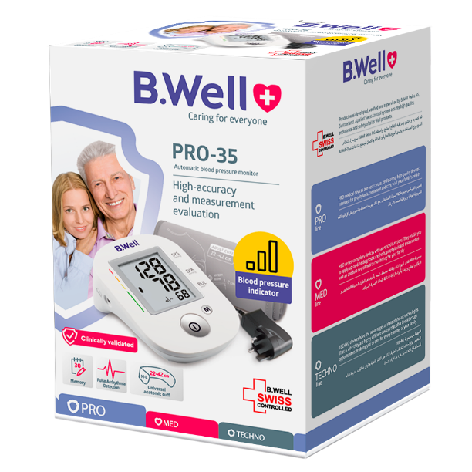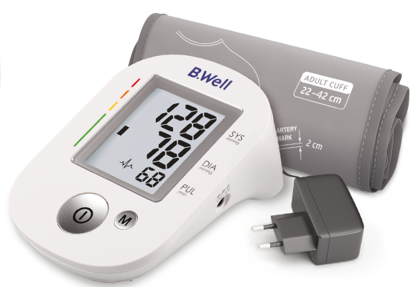
The B.Well PRO-35 automatic blood pressure monitor is a reliable measurement device. The PRO-35 provides accurate measurements and the immediate evaluation of results. Its blood pressure indication scale shows a range of pressure – normal, borderline, dangerous.
The PRO-35 automatic blood pressure monitor is comfortable and easy-to-use.

MED – 55 (G.iv )
B.Well Swiss
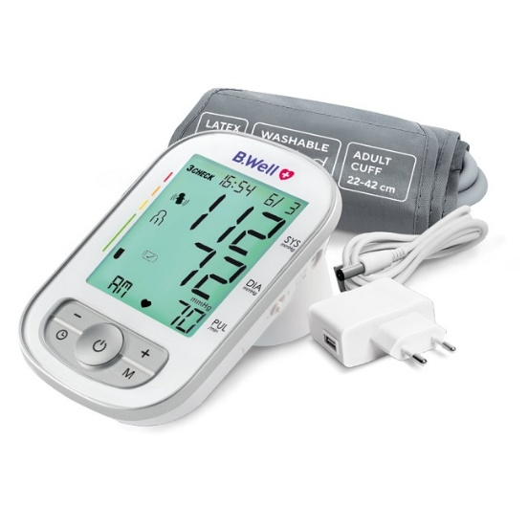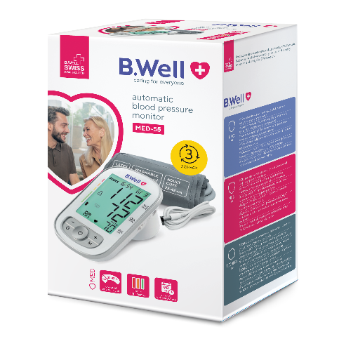

The MED-55 (G. IV) automatic blood pressure monitor is ideal for family use with 90 entries for 2 users. The device provides separate 7-day averages for morning and evening readings, helping you better understand daily patterns and adjust therapy when needed.

TH – 75
B.Well Swiss
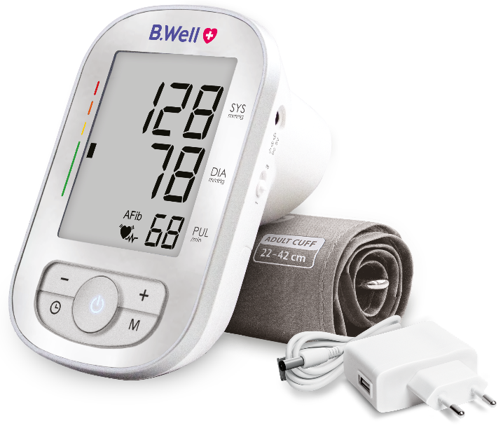

Introducing the first blood pressure monitor in our TECHNO line.
NEW B.Well automatic blood pressure monitor with AFib detection TH-75 is for use by medical professionals or at
home to measure the diastolic and systolic blood pressures and pulse rate.

- Aneroid Blood Pressure Kit

MED – 62
Stethoscope included - ready for use
B.Well Swiss

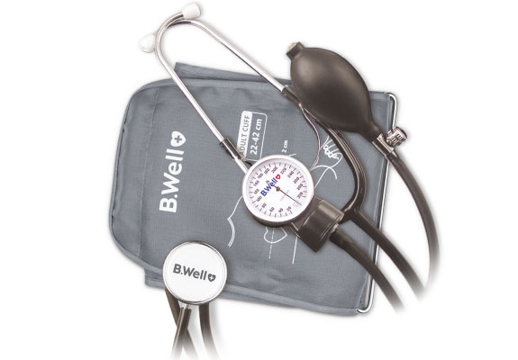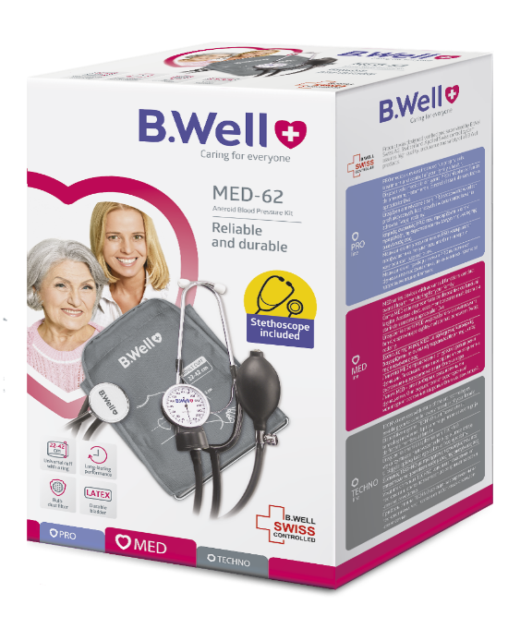
B.Well MED-62 is a classic aneroid blood pressure kit with a stethoscope.
MED-62 has a long-lasting metal gauge; durable latex bulb is equipped with a dust filter. Cuff for the upper arm with a circumference of 22–42 cm is reliable and convenient. The cuff is easy to put on thanks to a metal ring and specially rounded shape.

MED – 63
Built-in stethoscope for comfortable usage

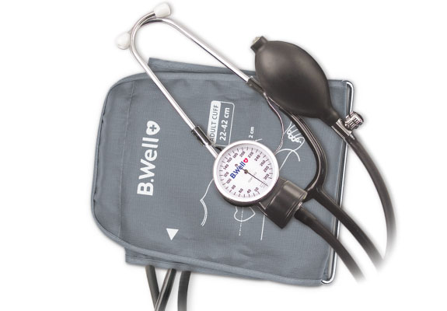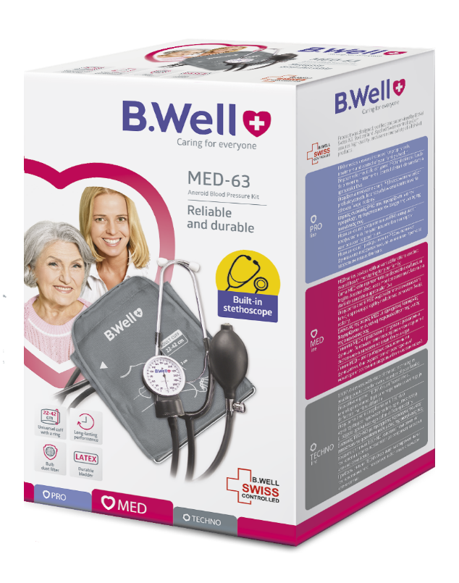

B.Well MED-63 is an aneroid blood pressure kit with a built-in stethoscope. Thanks to a built-in stethoscope and a cuff with a metal ring, MED-63 is also suitable for self-measurement of blood pressure. Accurate and reliable blood pressure monitor B.Well MED-63 is equipped with a metal gauge and convenient indication scale.

- Nebulizers

PRO – 110
B.Well Swiss
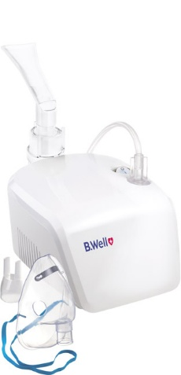

The B.Well PRO-110 compressor nebulizer is on par with professional devices and complies with European standard EN-13544 for nebulizers.
The particle size ≈ 3.16 μm allows medication to penetrate deep into the desired lung area for quick recovery, and the nebulization speed 0.4 mL/min shortens the procedure’s duration.

PRO – 115
B.Well Swiss
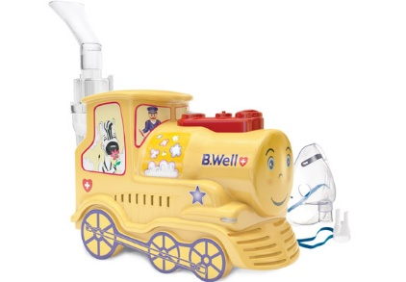

The B.Well PRO-115 compressor nebulizer for children and adults ensures professional therapy and fast relief for coughs, bronchitis and other respiratory tract ailments. An attachment for nasal inhalation included in the complete set allows the nebulizer to be used in the event of nasal congestion

MED – 120
B.Well Swiss

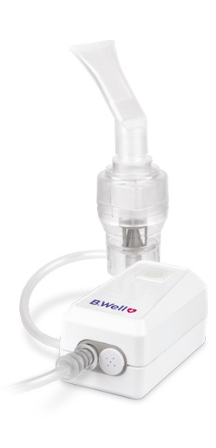

Quiet and compact B.Well MED-120 compressor nebulizer is the right choice for your health.
Compact nebulizer, dimensions (100 х 54 х 51) mm, convenient to use and easy to store.
Low noise level (equivalent to rain) is unique for a compressor nebulizer.
- Electric massagers

MED – 420
B.Well Swiss
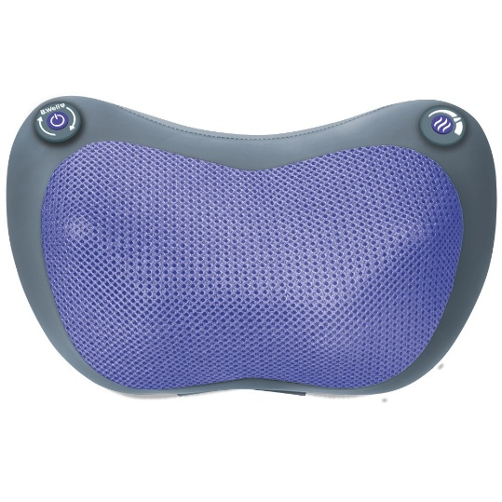

B.Well massager MED-420 is designed for a deep relaxing massage of the neck, lower back, feet, shoulders, calf muscles, thighs, buttocks. The massager's work is based on the principles of Shiatsu massage. This massage method involves the impact on certain points on the body by alternating pressure with the fingertips and the palms.

MED – 440
B.Well Swiss

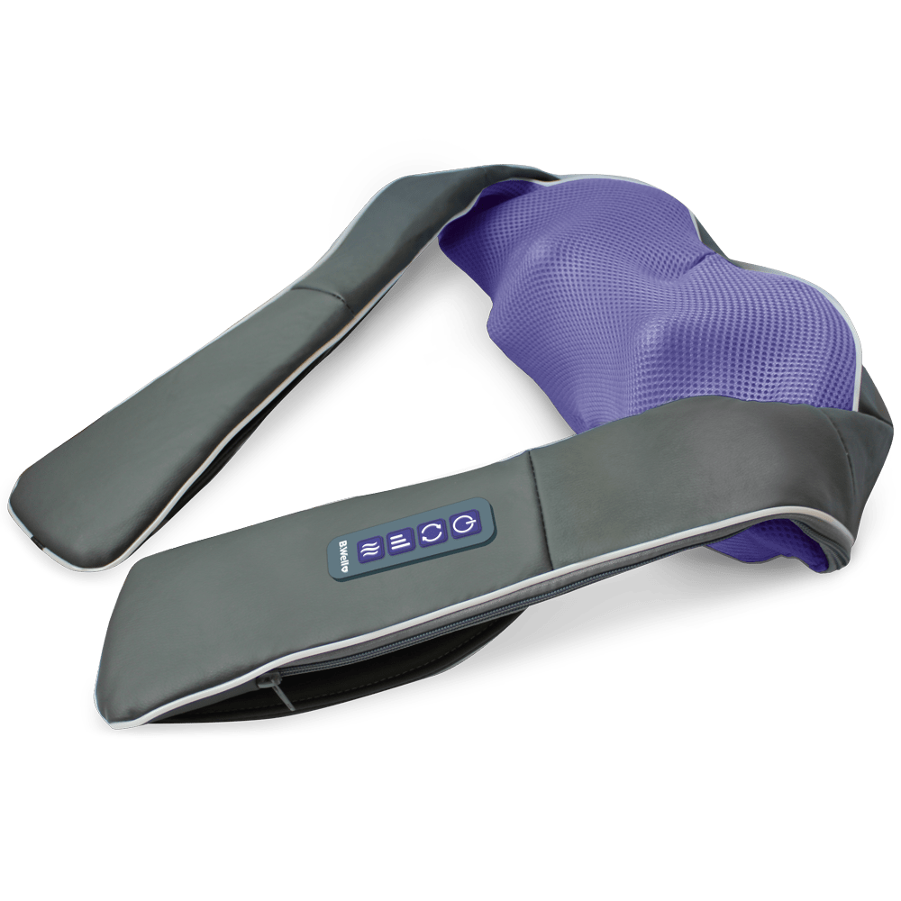
B.Well massager MED-440 is designed for recovering massage of neck, lumbars, feet, shoulders, calves, thighs and buttocks. It is based on a combination of Shiatsu and tapping massage techniques. Alternating pressure of palms and thumbs with light pressure on reflexogenic points helps to effectively cope with accumulation of salts, relieves muscle tension and spasms, improves blood flow and reduces stress. The massager helps to restore strength at home and at work.
- Digital thermometers

PRO- 04
B.Well Swiss
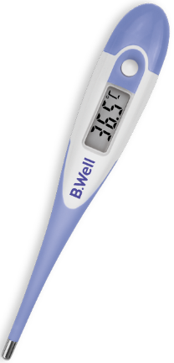
Digital thermometer B.Well PRO-04 will replace a mercury thermometer in your household first-aid kit. Unlike a mercury device, the electronic thermometer B.Well is completely safe, contains no mercury or glass, suitable for children and adults, and can be easily taken along. As much as all family electronic thermometers B.Well, PRO-04 has a removable battery and waterproof design. It has a flexible tip and ensures a gentle skin touch. Temperature measurement is quick and takes about 30 seconds.

WT-04 standart
B.Well Swiss

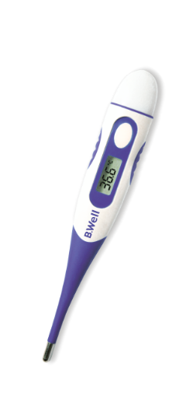

Digital thermometer B.Well WT-04 will replace a mercury thermometer in your household first-aid kit. Unlike a mercury device, the electronic thermometer B.Well is completely safe, contains no mercury or glass, suitable for children and adults, and can be easily taken along. As much as all family electronic thermometers B. Well, WT-04 has a removable battery and waterproof design. The model is characterized by increased comfort, has a flexible tip and anti-slip inserts. Temperature measurement is quick and takes about 30 seconds.

